Build Better Futures with PMI Sydney!
By Julia Checchia, Director Building Better Futures
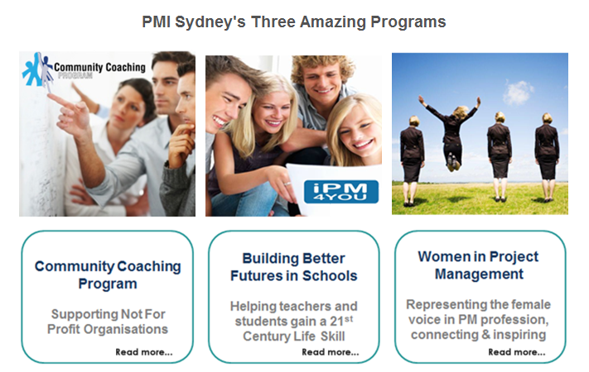
Are you ready to join a team of professionals who are determined to make a difference?

Let me walk you through what is happening in the Building Better Futures (BBF) portfolio to see if you answer can be a definitive yes?

Since August, we have been recruiting volunteers and getting a core team together for BBF. We are now getting momentum and I look forward to counting on you to make the exciting initiatives below, a reality:

- WiPM – we are looking for a Lead, we have a couple of names that may be able to help so that we can continue running the great value events that WiPM has been running since 2010.
- Community Coaching Program – we are planning to have a 1 day project management master class for not for profit organisations – we are looking for a venue sponsor and will be releasing the invitations out soon. Any help you can offer, please contact us.
- Schools program – we are planning to run a High School Principals breakfast late October – we are looking for a venue/catering sponsor as well. The aim of this breakfast is to gage Principals’ appetite to include project management in their high school curriculum even if within the existing subjects. Any help here is also very much appreciated.

Please contact buildingbetterfutures@pmisydney.org if you would like to support any of the above initiatives.
Good things happen when you get involved with PMI Sydney!

